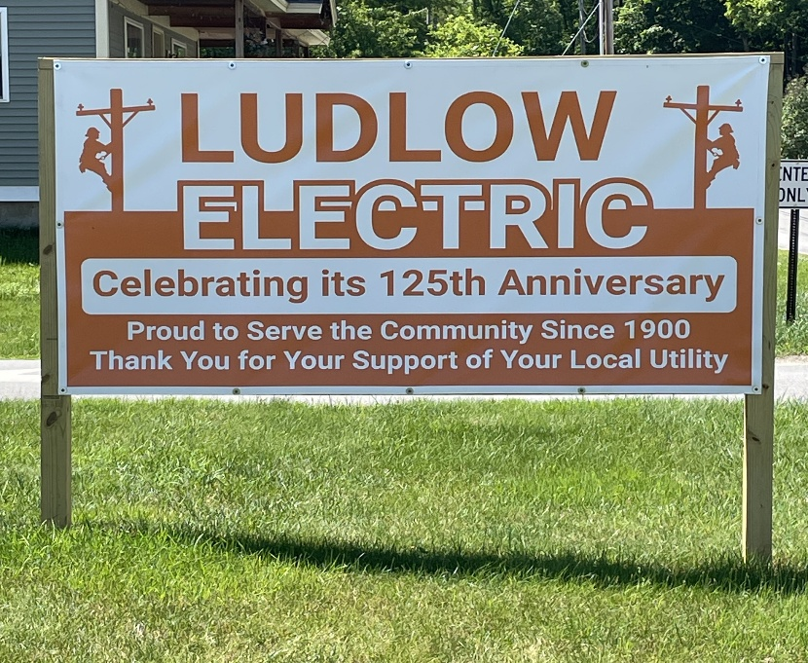
Ludlow Electric Department Manager
Ludlow, Vermont
The Organization
Ludlow Electric Department is a stable municipally owned utility that began in 1900. It has provided reliable power for 125 years while meeting the demands of the growing community. It has 3,800 customers and $9.2 million annual revenues.
The Position
Ludlow Electric is seeking a skilled and experienced manager to continue the all-around excellence provided for 125 years. This is a great career and lifestyle opportunity. The successful candidate must possess strong leadership, organizational, planning, technical, financial and communication skills.
The Department Manager reports to an elected three-member commission that meets monthly and other occasional meetings as needed.
The Manager has five direct operational reports, Outside Operations Manager, and Comptroller, HR/Admin/AP, billing coordinator, and customer service/collections. Other employees are Lineman Supervisor/Safety Officer, two linepersons, two apprentices and an electrician. See organization chart on website at www.ludlowelectric.com.

General Duties and Key Responsibilities:
- Lead the overall operation and direction of the utility with focus on planning, efficiency, and service excellence.
- Provide vision, leadership, and hands-on engagement to ensure successful operation of the utility.
- Develop and manage the annual budget, and a 5-year capital budget.
- Collaborate with the Board of Commissioners, staff and customers to maintain strong governance and transparent communication.
- Work closely with the Outside Operations Manager, Safety Officer and HR Officer to support personnel policies, operational safety, and promote efficiency and cost effectiveness with all their tasks.
- In coordination with the Comptroller, prepare and present financial statements in compliance with FERC, GAAP, and GASB standards.
- Evaluate training needs and support professional development.
- Serve as LED’s representative on the Board of Directors of the Vermont Public Power Supply Authority (VPPSA), actively engaging in monthly meetings and strategic planning.
- Participate in Public Utility Commission (PUC) and Department of Public Service (DPS) proceedings as necessary.

Qualifications:
- 10 years of managerial experience is a must, preferably in a municipal or utility setting.
- Bachelor’s degree in business administration, energy management, or a relevant discipline is desired.
- Experience working with and providing service to a Board of Directors.
- Working knowledge of utility regulations and requirements.
- Ability to positively encourage and supervise staff towards objectives, while acknowledging and supporting staff based on their individual needs and personalities.
- Ability to maintain positive, professional communications (both verbal and written).
- Knowledge of NISC utility software preferred.
The Community
Ludlow Vermont is a quintessential Vermont Town and the home of Okemo Ski Area. It is a vibrant community with a thriving and walkable downtown. The downtown area is complete with many unique shops and restaurants. There are excellent schools, a growing tax base and an expanding population. A local golf course adds to the recreational options. It is ideal for those seeking an outdoor lifestyle with a variety of four-season activities and it’s a wonderful place to call home. All this great stuff is close to major metropolitan areas, with Boston less than 3 hours and Montreal 3 ½ hours.
The Process
The first round of interviews will be conducted by three key staff members, two commissioners, and a recruiting consultant. The second round of interviews will be held by the Interim Manager, all Commissioners and a recruiting consultant.

The salary range: is $130,000-$150,000 with a generous benefit package. All health care insurance is paid in full by the Department (this is subject to change in future years) and it includes major medical from BCBS, dental coverage, vision coverage and a HRA. There are three retirements programs. LED is a part of VMERS, the statewide municipal defined benefit retirement system, which is mandatory and is paid by the Department, an IRA with a maximum employer 3% match, and a 457 plan. Employees may participate in any or all programs. Generous PTO is included. Relocation stipend will be offered.

To apply- Please email a resume and cover letter to Tom Yennerell, tyennerell@municipalmgtservices.com by August 10, 2025. The position is open until it is filled. Ludlow Electric Department is an EOE employer.

